**Final Assignment WBAD**

Nama : Dhiya Tsaltsa Muharram

NIM : 2702389745

Kelas : LA79

**Tautan Source Code dan Demo :**

1. **Source Code Github :** [**https://github.com/katsuumata/Final-Assignment-WBAD**](https://github.com/katsuumata/Final-Assignment-WBAD)
2. **Demo Github Pages :** [**https://katsuumata.github.io/Final-Assignment-WBAD/**](https://katsuumata.github.io/Final-Assignment-WBAD/)
3. 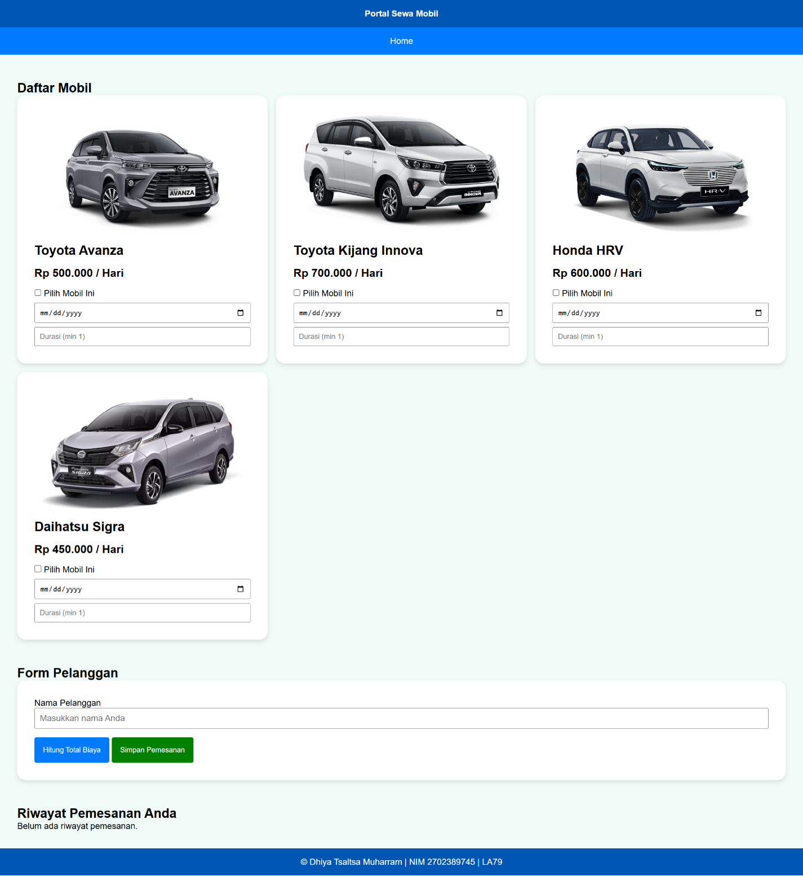**Tampilan Keseluruhan (Form Input Sewa)**
4. **Tampilan Validasi dan (3) berhasil disimpan ke local storage**

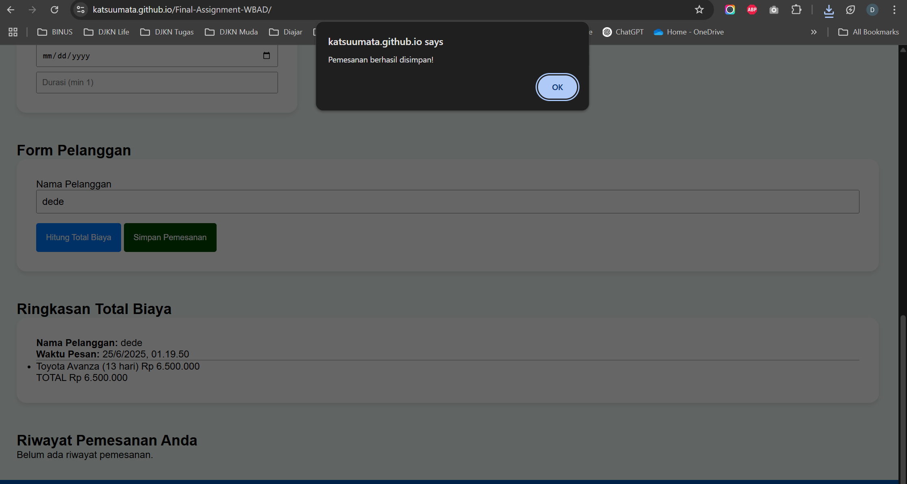

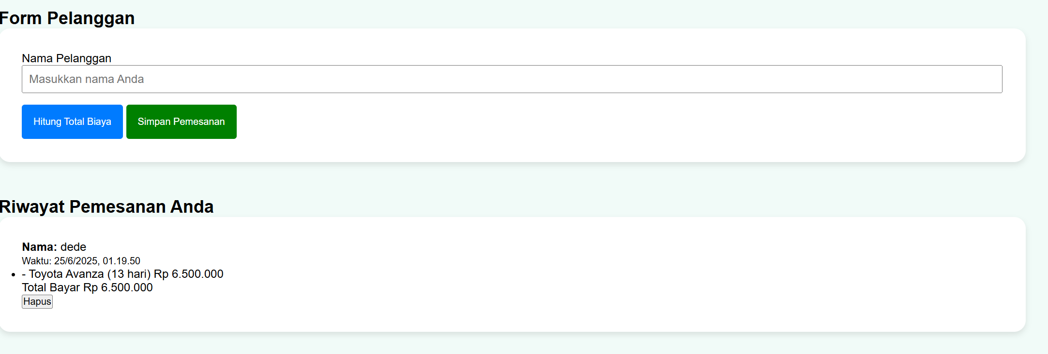

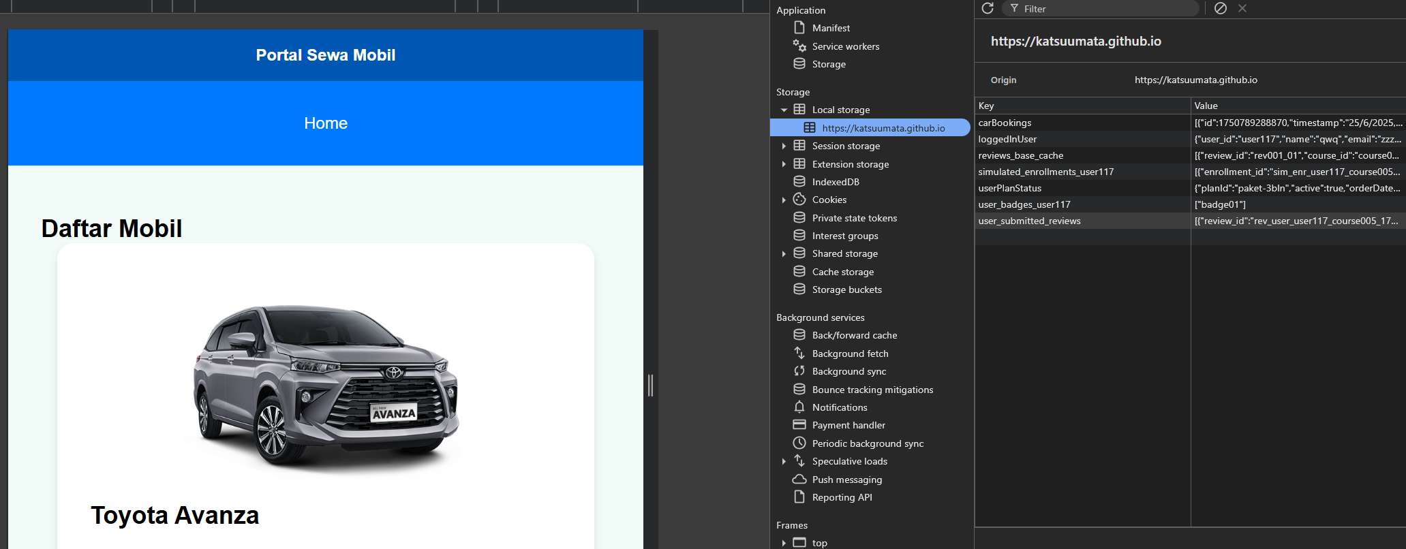

1. 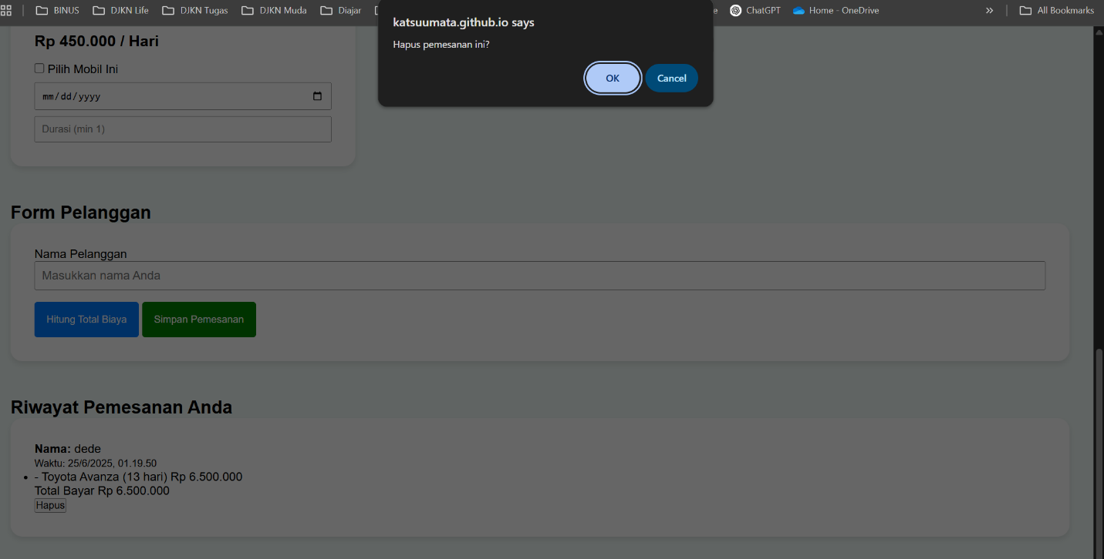**Tampilan Berhasil dihapus**

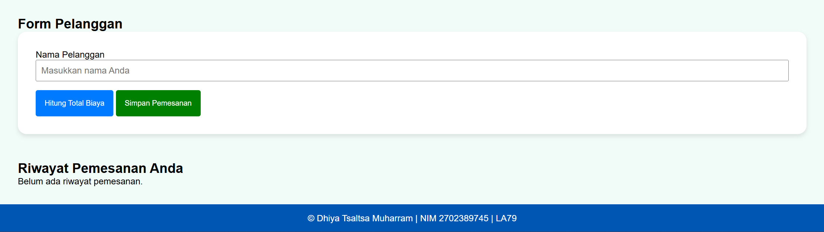

1. **Tampilan seluruhnya berhasil**

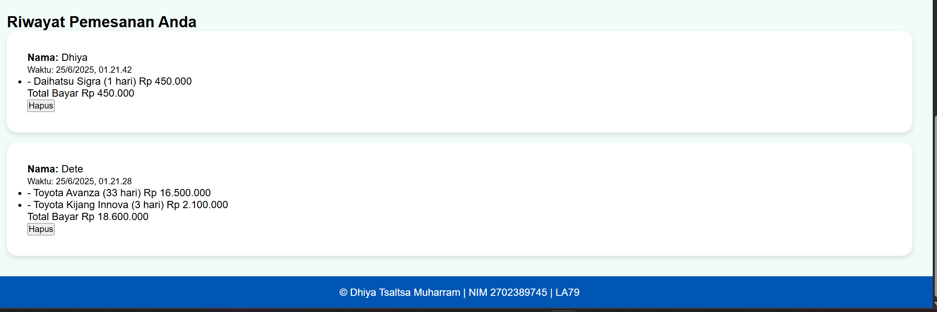

1. **Tampilan Mobile Friendly**

